Subject: Notice – Payment changes coming soon

Hello, <Your company name> has some exciting news!

We’ve partnered with Corporate Spending Innovations (CSI) to simplify and secure payments to you. As part of our setup process with CSI, they will contact you to confirm your preferred payment method. The payment methods available, in order of preference, are virtual credit card, ACH, and check. When CSI reaches out, they might email and call you. Below is a sample email from CSI that comes from noreply@csipaysystems.com. When you receive this email, click the link to register with CSI. Registering electronically through their secure form eliminates any potential follow-up phone calls.

After the initial setup, you’ll receive an electronic remittance for every payment made through CSI. This remittance outlines the payment details regardless of the payment method you choose. The remittance will be sent to the email address we have on file for you.

Thank you for your attention as we roll out this new service.

Payment considerations
- When you choose virtual credit card, make sure to include any credit terms or limits that your company has.
- When you choose ACH, it can take up to 5 business days to validate your bank account with a micro debit. No action is required on your part.
- For ACH payments, you’ll see a description on your bank deposits that starts with “888C……” for payments made through CSI.

Sample CSI Email

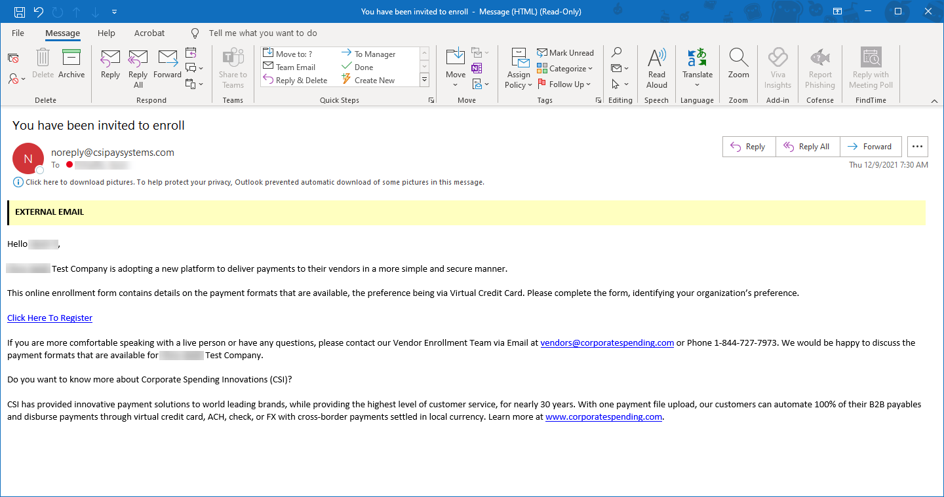

Regards,
<Your company name>

